Landscaping of Resource Partners for Rabies in [Country] – Template

Version 1, September 2022

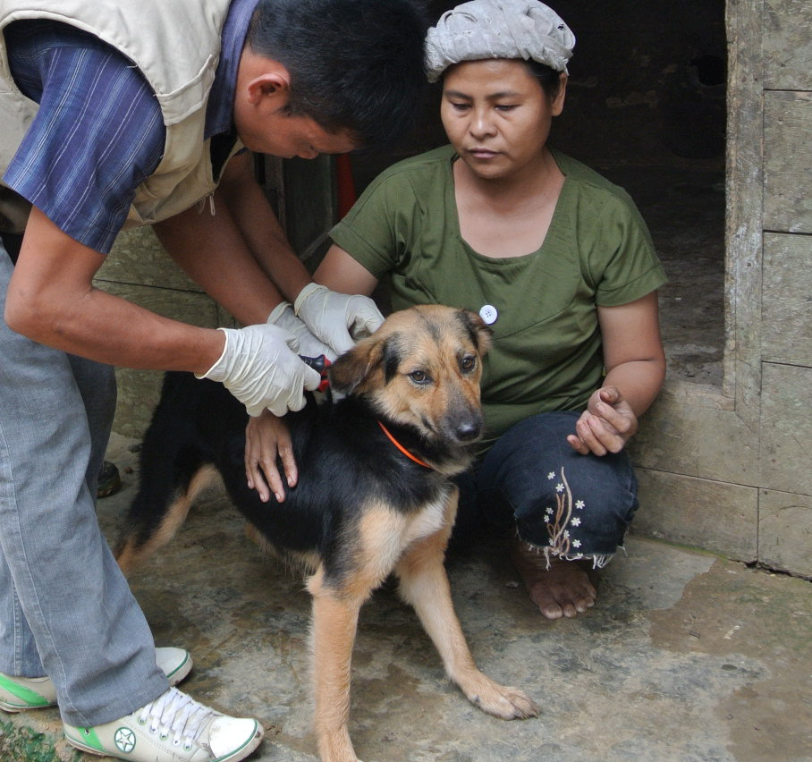
www.unitedagainstrabies.org
Photo credit: © WOAH

Instructions for Template

The United Against Rabies Forum is an inclusive network of stakeholders that support countries in developing and implementing effective rabies control and elimination programmes, in line with ‘Zero by 30: the Global Strategic Plan to End Human Deaths from Dog-Mediated Rabies by 2030’ (Zero by 30).

This template has been developed by Working Group 3 of the Forum, entitled ‘Advocacy and Resource Mobilisation’, to assist stakeholders in landscaping resource partners within their country that could support rabies prevention and control.

This document should support the development and implementation of a National Strategic Plan, by helping map stakeholders and their roles and responsibilities. A template for a National Strategic Plan can be found here.

Example headings, text and tables have been included for consideration. However, this is a guide only, and the author/s should adapt this as needed to ensure that this is fit for purpose for their own country.

The key objectives of this document are:
- To identify potential partners for resource mobilisation for rabies control in [Country]
- To profile the potential resource partners based on their current, past and projected future activities related to rabies control in [Country]
- To support the development and implementation of a National Strategic Plan in [Country]

Several methods can be employed to identify resource partners:
- Consultation of National Strategic Plan (if available)
- Consultation of known rabies stakeholders
- Detailed internet and literature search using key words and phrases related to rabies
- Contact www.unitedagainstrabies.org for information on known stakeholders and resource partners in your country or region

Acknowledgements:
- Dr Gbeminiyi Richard Otolorin, University of Jos, Nigeria
- Dr Junaidu Maina, JM Global Associates, Nigeria
- Dr Kavosa Mudoga, Action for Protection of Animals Africa, Kenya

Executive Summary

This section should summarise the key points of the document, restating the purpose, major findings and any conclusions and recommendations.

The author/s are encouraged to include a reference to the National Strategic Plan (if available), and note how this document can support the development and implementation of this plan.

The following example text could be included:

Dog-transmitted rabies is a zoonotic disease that causes the completely preventable death of an estimated 59, 000 people every year. The control of diseases such as rabies depends on the availability of sufficient resources, and it is therefore important to identify key resource partners.
The global community has committed to ‘Zero by 30: the Global Strategic Plan to End Human Deaths from Dog-Mediated Rabies by 2030’, and the United Against Rabies Forum was established in 2020 to support countries in reaching this goal. Countries need to drive efforts, by developing rabies prevention and control programmes, and mobilising domestic and international resources to effectively and sustainably implement these programmes.
For planning purposes, it is key to identify agencies/organisations that have funded rabies prevention programmes/initiatives in the past, and also identify potential resource partners that are critical in providing required resources (e.g. equipment, consumables, infrastructure).
The key objectives of this document are:
- To identify potential partners for resource mobilisation for rabies control in [Country]
- To profile the potential resource partners based on their current, past and projected future activities related to rabies control
- To support the development and implementation of the [name of National Strategic Plan in country]

List of Acronyms

- Acronym – Organisation
- Acronym – Organisation
- Acronym - Organisation

Introduction

This section should explain in 1-2 paragraphs what rabies is, and the threat it poses in [Country]. Context should be provided on the global burden of rabies, including global efforts on rabies prevention and control.

This section should include the purpose of this document, and how this will support national control efforts. If a National Strategic Plan is available, reference to when this was developed, and where it can be accessed, should be included.

Resource Partners

This section should briefly list the potential resource partners that could contribute to rabies control in [Country].

A list of potential resource partners could include:

- Global Banks
- Regional development banks
- Multilateral donors
- Government budgets
- United Nations, International Governmental Organisations, Non-governmental Organisations
- Corporations, local and international industries, Foundations and Philanthropists
- Community Crowdfunding
- Individual donors

Resource Partner

Provide a short overview of the listed resource partner, including:
- Involvement/relevance to rabies activities
- Key responsibilities
- Where to find further information (e.g. contact details, website)

Resource Partner

Provide a short overview of the listed resource partner, including:
- Involvement/relevance to rabies activities
- Key responsibilities
- Where to find further information (e.g. contact details, website)

The below example tables could be useful in organising resource partners.

Table 1. Organisations that can provide financial support for rabies control
Organisations that can provide financial support for rabies control
Organisation | Key responsibilities | Contact

Table 2. Organisations that can provide equipment, disposables, laboratory diagnosis/support
Organisations that can provide equipment, disposables, laboratory diagnosis/support

Organisation | Key responsibilities | Contact

Table 3. Organisations that can provide educational material to support rabies control
Organisations that can provide educational material to support rabies control
Organisation | Key responsibilities | Contact

Table 4. Organisations that can provide rabies prevention biologicals (e.g. rabies vaccine, rabies immunoglobulin)
Organisations that can provide rabies prevention biologicals (e.g. rabies vaccine, rabies immunoglobulins)
Organisation | Key responsibilities | Contact
Table 5. Organisations that can provide logistics/planning/surveillance (e.g. transportation, storage) for rabies control
Organisations that can provide logistics/planning/surveillance (e.g. transportation, storage) for rabies control
Organisation | Key responsibilities | Contact

Table 6. Organisations that can provide research support and field veterinarians that can support rabies control
Organisations that can provide research support and field veterinarians that can support rabies control
Organisation | Key responsibilities | Contact

